**HTML Level 2**

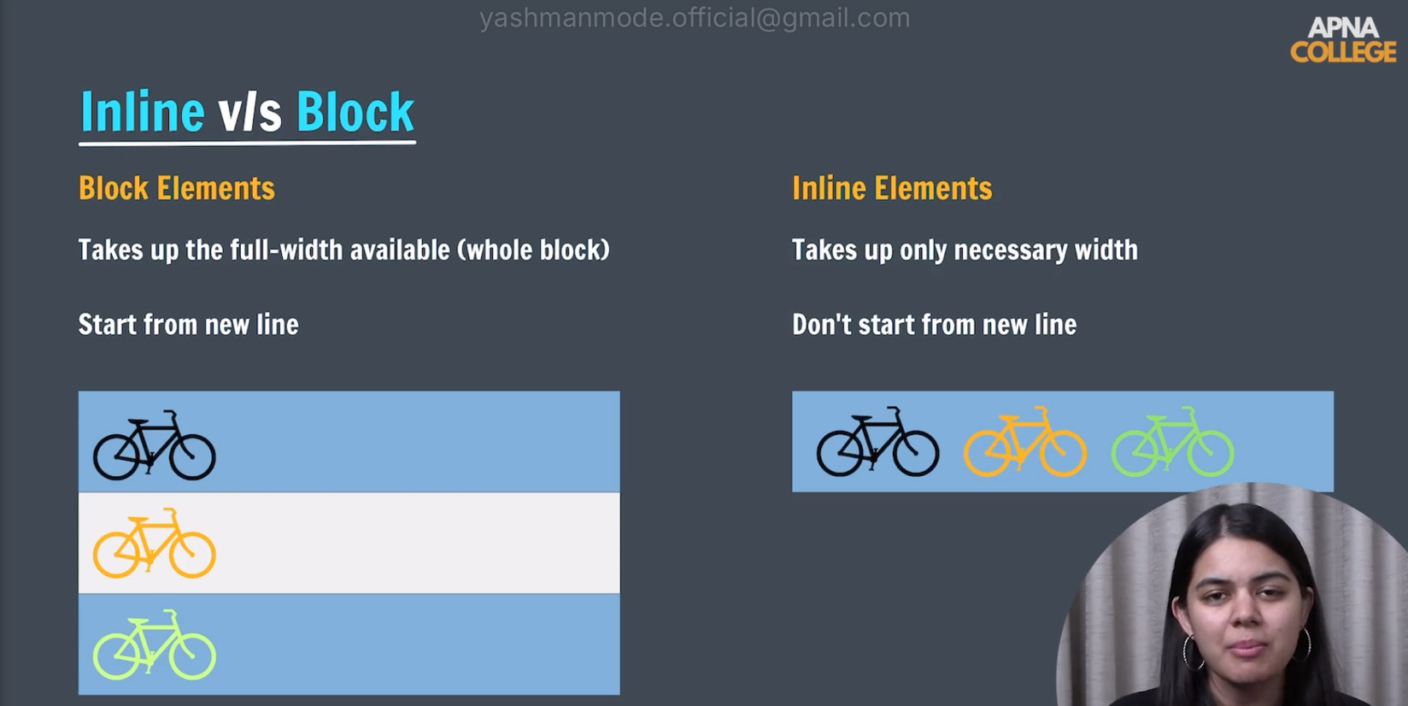

This setting can be used in the CSS Display property.

**The span element** is inline, but **p and div** are block elements**.**

There are two special tags: "sup,” which is superscript, and “sub,” which is subscript**.**

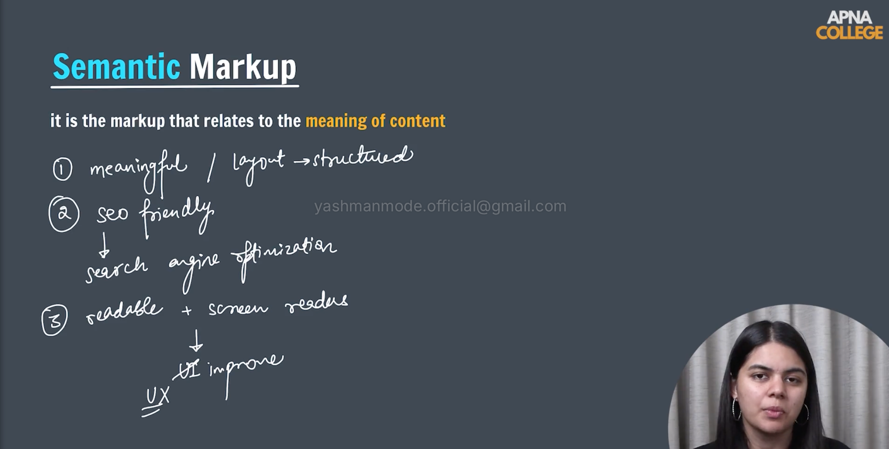**Eg: A2 = A <sup>2</sup>**

Read more about HTML in [HTML MDN](https://developer.mozilla.org/en-US/docs/Web/HTML)

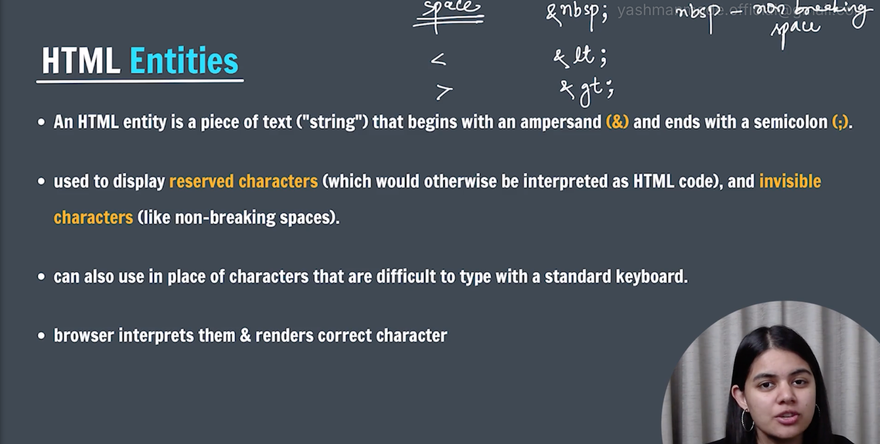

More on [Character Reference](https://html.spec.whatwg.org/multipage/named-characters.html#named-character-references).